**DALAC**

**Workspace Management System**

**Deliverable 4**

IS 436 – Structured Systems Analysis and Design

May 14, 2018

David Luco

Amanda Ali

Luke Stigdon

Anita Sharma

Collin Sullivan



**ER Diagram**

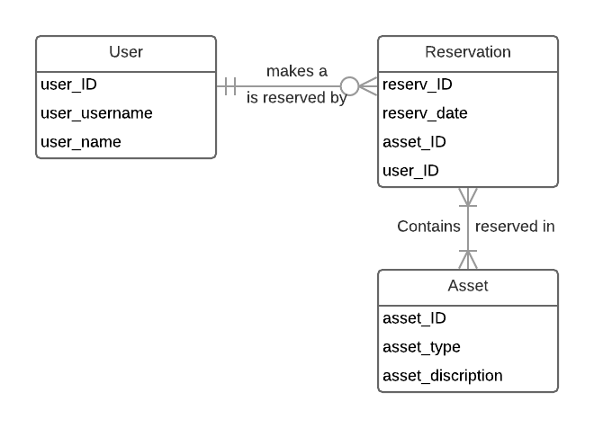

**Textual Description**

***User:*** Is an employee of the company, either a basic employee, member of the HR department, or upper management. Each user is able to create a reservation for work space or objects. HR and upper management users have special functions available to them to maintain and control their workers.

***Reservation:*** Is created to reserve a workspace or work object for an employee. Reservations cannot overlap for the same user but can be reserved for extended periods of time. Reservations can be made on mobile and desktop applications.

***Asset:*** Is either a room in the building or a piece of equipment that can be reserved for use. Each asset must be reserved and cannot be used for extend time unless it is reserved again.

**Individual Alternative Matrices**

*Amanda’s Alternative Matrix*

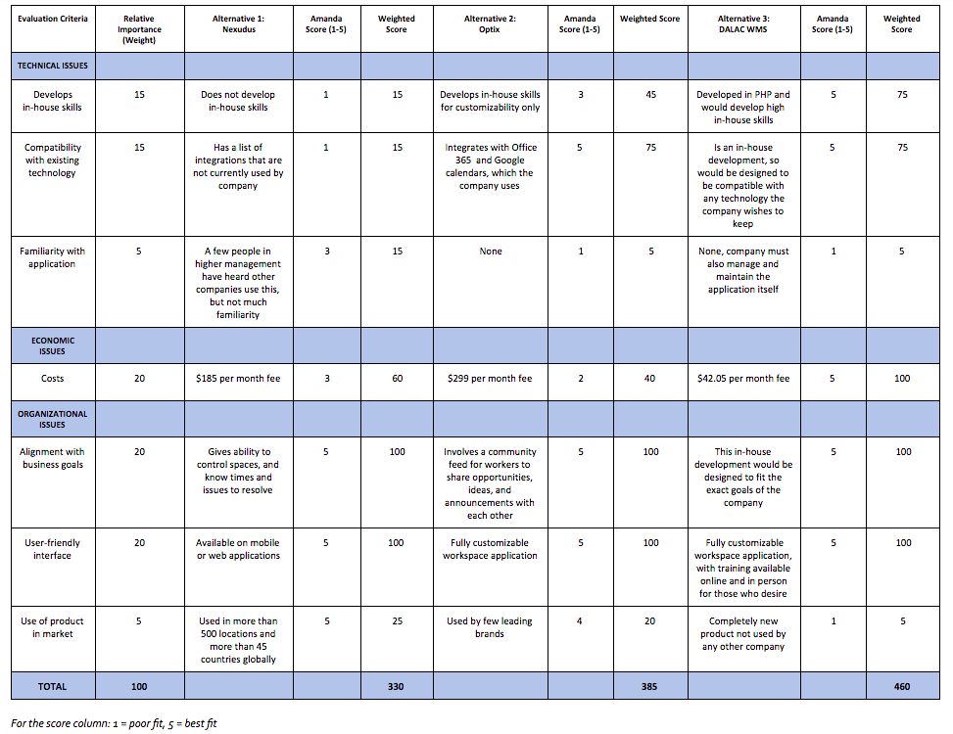

*David’s Alternative Matrix*

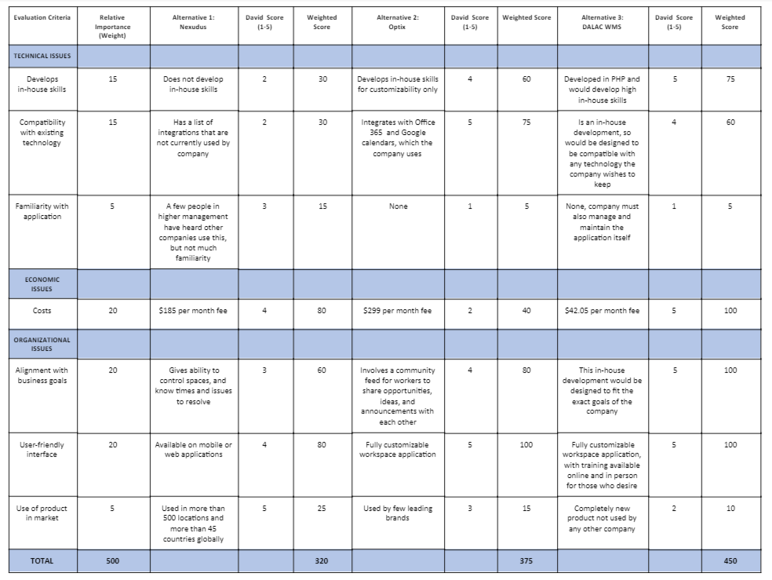

*Anita’s Alternative Matrix*

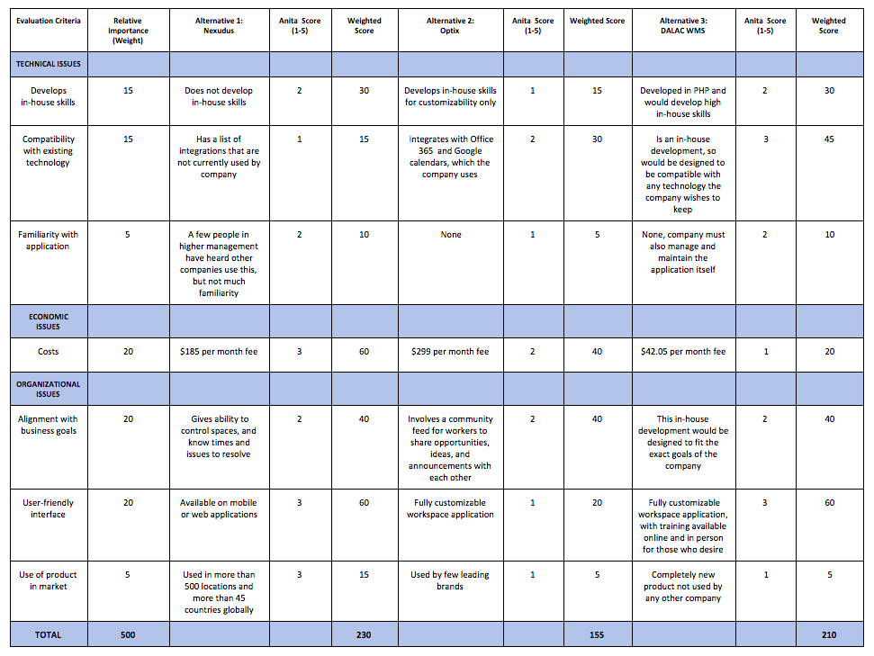

*Collin’s Alternative Matrix*

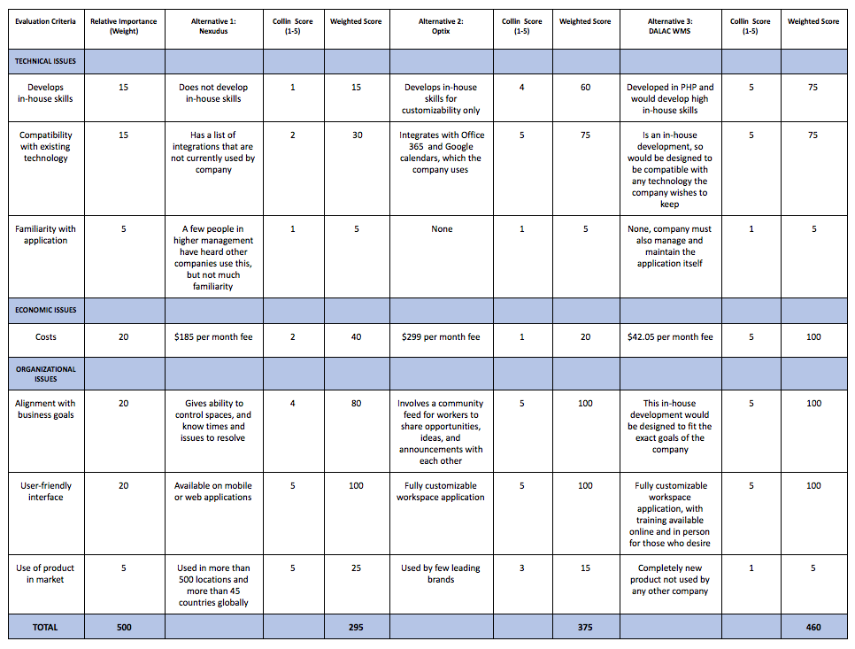

*Luke’s Alternative Matrix*

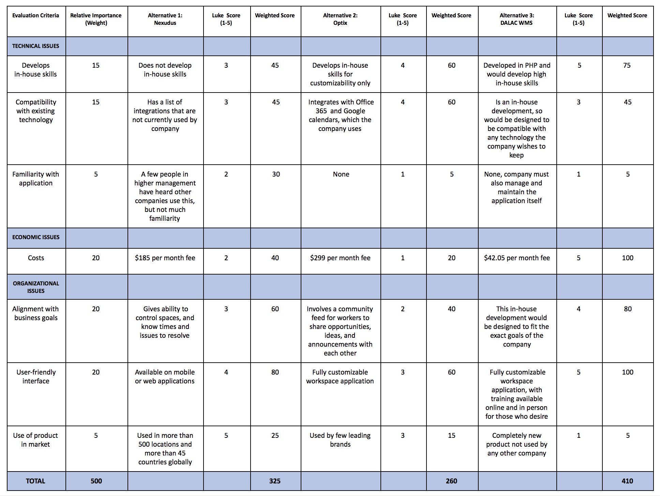

***ALTERNATIVE 1: NEXUDUS***

* Nexudus is a tool used to manage office space that was created in 2012. Information from each company is imported into the tool through integrations, however there are no in-house skills developed from this tool due to do being already developed and auto-generated. It gives users the ability to book office spaces online, see how long users were in certain rooms, and resolve any issues with progress efficiently. Nexudus is available on mobile, tablet, and web applications, and is well-known globally due to it being used in more than 45 countries around the world. The tool would cost about $185 per month for the company to use.

***ALTERNATIVE 2: OPTIX***

* Optix is also a tool that helps modernize coworking management software. It is a mobile and web application that allows users to book space and access the tool anywhere. It provides information in real-time for each space when involving booking times, availability, and analytics. Users may also publish on a community feed about any opportunities, ideas, or announcements for other users to see. In-house skills are only available for customization, but the tool integrates Office 365 and Google calendar, which the company uses. Optix would cost about $299 per month, and is used by a few leading brands.

***ALTERNATIVE 3: DALAC WMS***

* DALAC WMS is a server-based web application developed in PHP. It highly encourages improving in-house skills due to it being a complete in-house development causing the team to fully learn the ins and outs of the system. The team also has the ability to fit the exact needs of the organization, however they must constantly manage and maintain the application due to it being an in-house development. Offloading the infrastructure to AWS allows for a reduction in hardware and maintenance costs as well. DALAC WMS would cost about $42.05 per month. The application is also a fully customizable workspace application with training available in person or online for any users who wish to use it. The application allows users to check availability of current and future office spaces while also having the ability to alter or delete any of their reservations. Management has the ability to see who is authorized to be in each room, how long someone has been in each room, and what work each person was accomplishing during their reservation.

**Team Alternative Matrix**

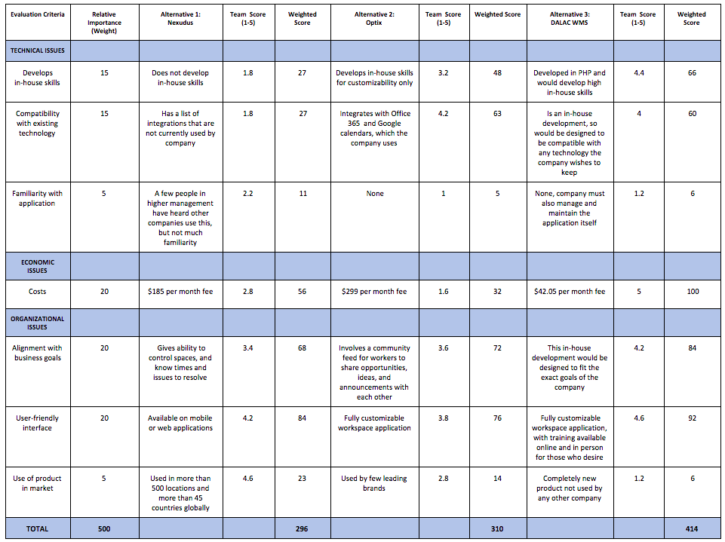

***FINAL TEAM DECISION: DALAC WMS***

* Our team decided to choose the third alternative, which was to create and implement our own workspace management system called DALAC WMS. There were a multitude of reasons as to why we chose this option. When focusing on technical issues, it was the top alternative that gave users the opportunity to learn in-house skills. Also, due to it being created from scratch, it gives the company an opportunity to make the tool be designed to be compatible with any current or future technology they desire. When focusing on economic issues, it was the alternative that had the cheapest monthly fee compared to the other alternatives. When focusing on organizational issues, the tool would be designed to fit the exact goals of the company due to it being an in-house development. It would also be a fully customizable workspace application, and since it requires more on-hands work, training would be available online or in person to whichever user wishes to receive it. Although this choice might require the most work in development, we believe that it will be the most worth it in the end due to it allowing the company to customize their needs into the tool.

**Architecture Matrix**

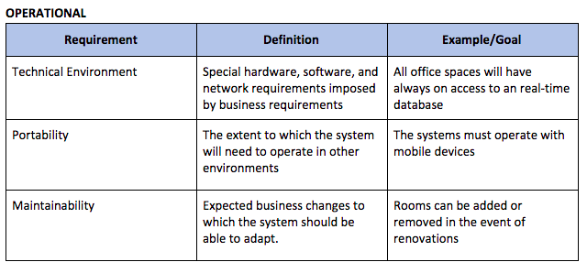

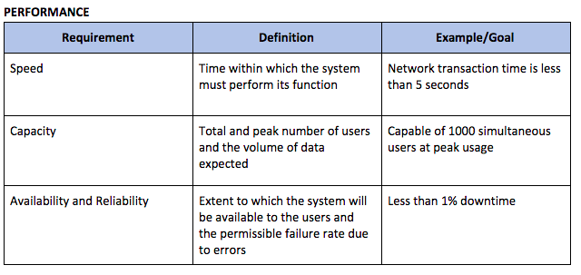

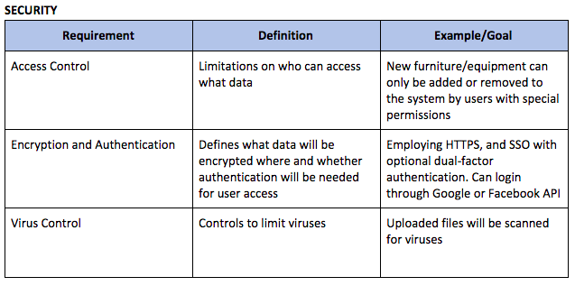

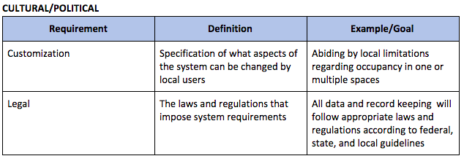

**Decision of System Architecture**

Based on our Operational, Performance, Security, and political requirements we chose ***client –server architecture.***

Reasons for selecting client-server model:

* *Provides higher scalability*

Resources in the form of network segments, computers and servers can be added to a client server network without major interruptions to the network. Access to any new resources can be administered from the centralized security database, stored on a single network server.

* *Increased productivity*

Deployment of client/server computing will positively increase productivity through the usage of cost-effective user interfaces, enhanced data storage, vast connectivity and reliable application services.

* *Easy Maintenance*

It is easy to replace, repair, upgrade and relocate a server while clients remain unaffected.

* *Security*

Servers have better control access and resources to ensure that only authorized clients can access or manipulate data and server updates are administered effectively***.***

* *Remote Access*

Servers support remote access which enables employees, partners, and customers, to access data on the server without physically being in front of the system.

Disadvantages of using client – server model:

* Off premises hosting solutions can impact availability
* Security/Privacy considerations when hosting data remotely

**Hardware and Software Specification**

* ***Hardware***
  + AWS EC2 Instance (t2.small) - or equivalent
  + AWS RDS Instance (db.t2.small) - or equivalent
* ***Software***
  + Operating system: CentOS
  + Database Engine: MySQL
  + Web Application: PHP >= 7.1
    - Laravel Framework 5.6
  + Web Server: Nginx or Apache
  + Client: Any modern web browser (e.g. Firefox, Chrome, Edge, Safari)

**Updated Project Plan**

